The personality quiz

What are you like?
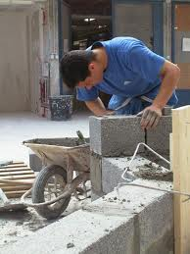
¤ patient
¤ touchy
¤ impolite
¤ hard-working

What do you like doing at the weekend?

¤ doing homework
¤ playing video games
¤ watching TV
¤ listening to music

What did you do last weekend ?

¤ Played rugby ,football,handball…
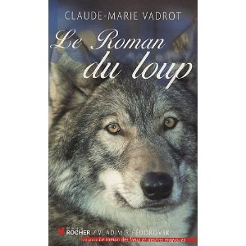
¤ Played video games
¤ did homework
¤ read
¤ helped around the house

Do you have?

¤ loads of dreams
¤ loads of fun
¤ loads of secrets

Which rugby team do you like watching on TV ?



¤ Toulouse
¤ Toulon
¤ Stade Français
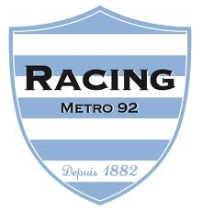

¤ Massy
¤ Racing metro

What animal are you?
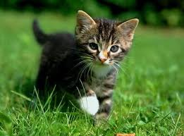

¤ A dog
¤ A cat
¤ A Turtle
¤ A Horse
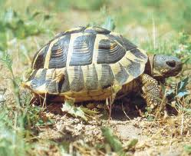
¤ A Fish


