The ULTIMATE
PERSONALITY quiz
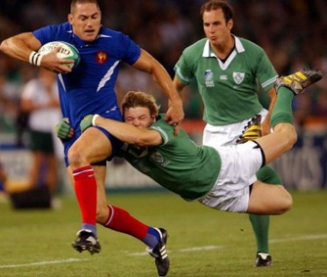
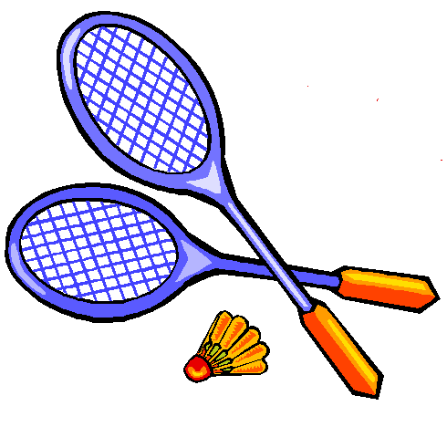
①Do you like sport ?

Yes
No
❑ Baseball  Football  Dance
❑ Rugby  Badminton

②Do you have …
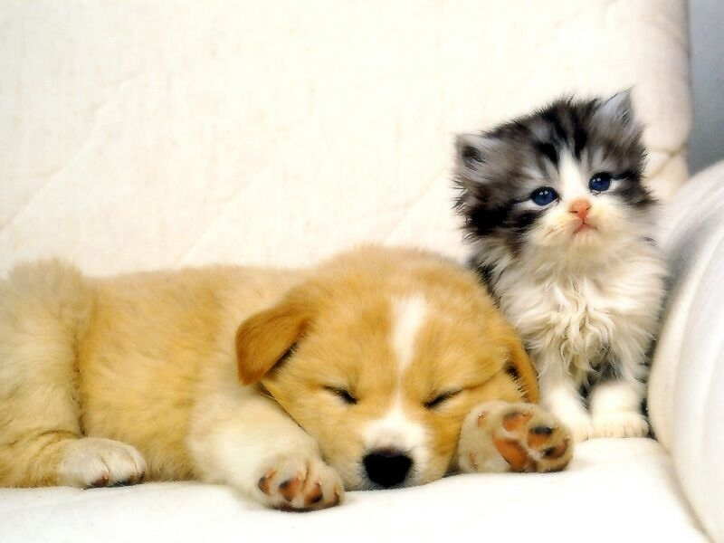
 loads of secrets  loads of pets  loads of dreams
 loads of friends  loads of fun

③ What do you like doing on a Saturday ?
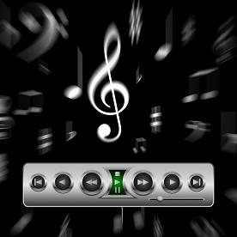
 Listening to music, surfing the net,  Others ......................
playing video games, watching TV or reading  Looking after your
 Cooking, gardening, decorating brothers or sisters
 Hanging out with your friends downtown  Helping around the house

④What animal are you ?
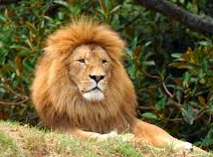
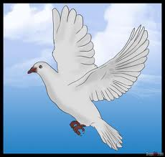
✰ A lion ➔ a born leader  Others ..............
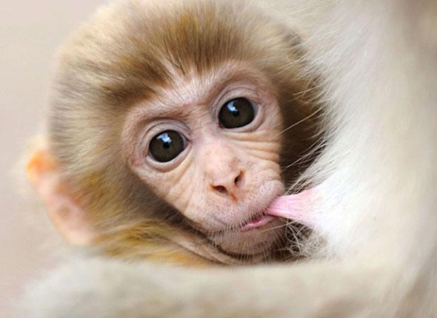
✰ A dove ➔ you have a happy-go-lucky approach to life
✰ A dog ➔ your friends can count on you
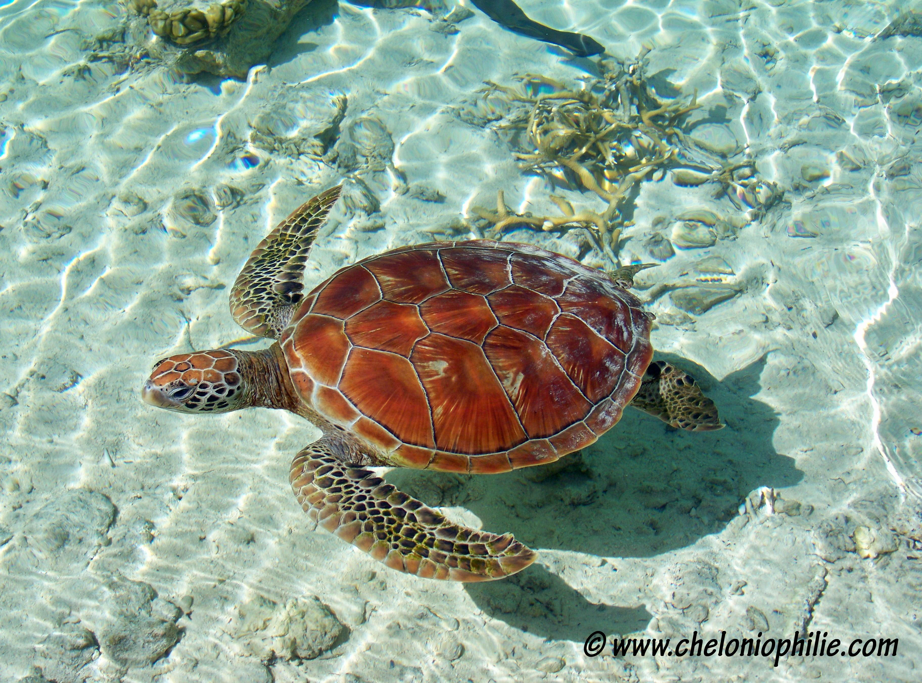
✰ A monkey ➔ you love it when you are the centre of attention
✰ A turtle ➔ you like peace and harmony

⑤What are you like ?

Polite Touchy Flexible Honest
Patient Fun-loving Caring Shy
Responsible Easy-going Hard-working Bold

⑥When do you do your homework at the weekend ?

◻Friday afternoon ◻Sunday afternoon
◻Saturday morning ◻Sunday morning
◻Saturday afternoon

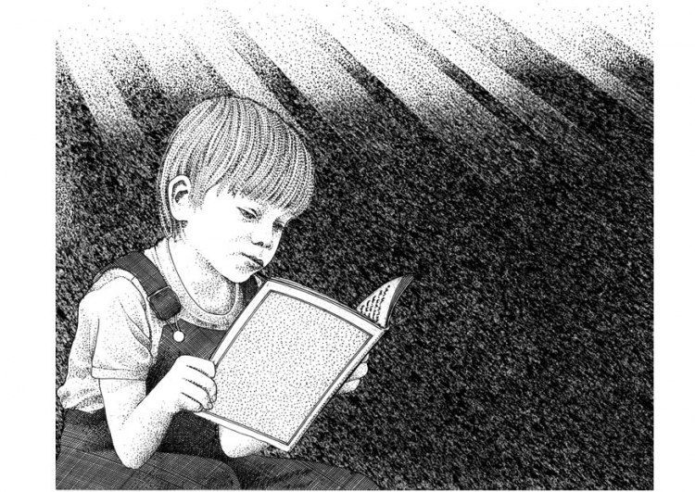
⑦What can't you live without ?

 My books and magazines Others......................
My music and CDs My pets
My techy stuff (computer, mobile phone, Mp3)

