Our school «The Two Rivers»

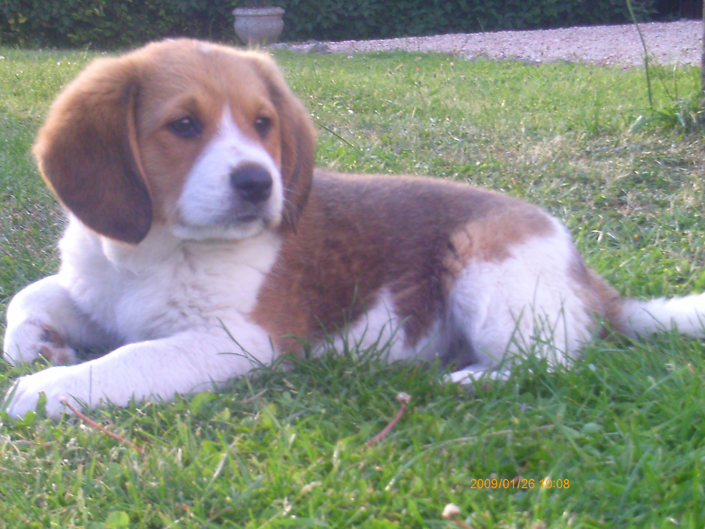
The Two Rivers is situated in Moulins-Engilbert in Nièvre,in France.It is a secondary school and a state school.It was
founded in 1959.There are 221 students and 20 teachers. The mascot of 4A is Gadjo Clark's dog.
The curriculum is varied, there are:Maths,English,History,Geography,Science,Music,P.E,Art,I.T,Spanish,Physics and Study.The schedule starts at 8.25 , there are 3 or 4 lessons in the morning . We have lunch at 11.30 or at 12.30. Between 12.30 and 13.25 there are clubs, choir or help with homework. There are 3 lessons in the afternoon.Students leave school at 4.30 p.m.After 4.30 the students can go to help with homework or a detention . The hall and the school life office are situated at the main entrance . On the right there is a covered playground and a playground. Under the covered playground there are a lockers.To the left of the covered playground there is a classroom and to the right there are 14 classrooms. In front of the school life there is a playground. To the left of the playground there is an English classroom and on the right there are kitchens and a dining hall.Well that's about it.I love my school because the teachers are very nice.The school is very pleasant.

bus park
Building A
Green areas
Building A
Bike shed
Dining hall
Toilets
Toilets
Covered
playground
Building B

Playground Playground
Classroom2
Science

Classroom19
I.T
Building A
Corridor Hall
Bursar's office
Secretary's office
The Head
Staff Room
Classroom1
Physics
school library
Sickroom/
Careers
advisor
n

education
advisor
School life
office

Kitchens

Dining hall

Playground

Building B
Corridor
Classroom6
Study
Room7
Foyer
Classroom5
Computer room
Classroom3
French
Classroom18
Maths
Classroom17
French
Classroom16
Spanish
Classroom15
English
Classroom14
History
Classroom11
Art/Music
Classroom12
Study
Ground floor
Classroom4
Maths

Corridor

Classroom13
History
First Floor

