Our School
The Two Rivers

The Plan of our school
Hall and Ground Floor

First Floor

The Two Rivers is situated in Moulins-Engilbert, in Burgundy. It was founded in 1959. It's a state school and a day school since the students and the teachers go back home when it's the end of the lessons. The class mascot is Baboon, Myra's cat. There are 220 pupils and 16 teachers. The curriculum is varied : the students can study the usual subjects like English, Maths, History, etc. But they can also study Music, Art, Sport, Technology and Latin. Sport is very important at the Two Rivers too: you can go to the UNSS, an association for different sports, there is a cross country race at the beginning of the school year and there is a trip during a week in Lamoura for swimming and to practise different activities. Our schedule starts at 8.30 in the morning, when we have the first lessons, and we have three lessons after that. Next, it's lunch time, and we can go to clubs but it's not compulsory. After that, we have three lessons and then it's time to take the bus and we go back home. The life school office is situated in the center of the school, next to the Education Advisor's office. When you enter the school, there is a playground on the left and one opposite. The library is next to the Physics classroom and the Head teacher's office is near the secretary's office. The I.T. building is behind the dining-hall and next to the nursery school. There is a gym and a swimming-pool near the school but they are not school possessions. I like my school because we can do different sports.
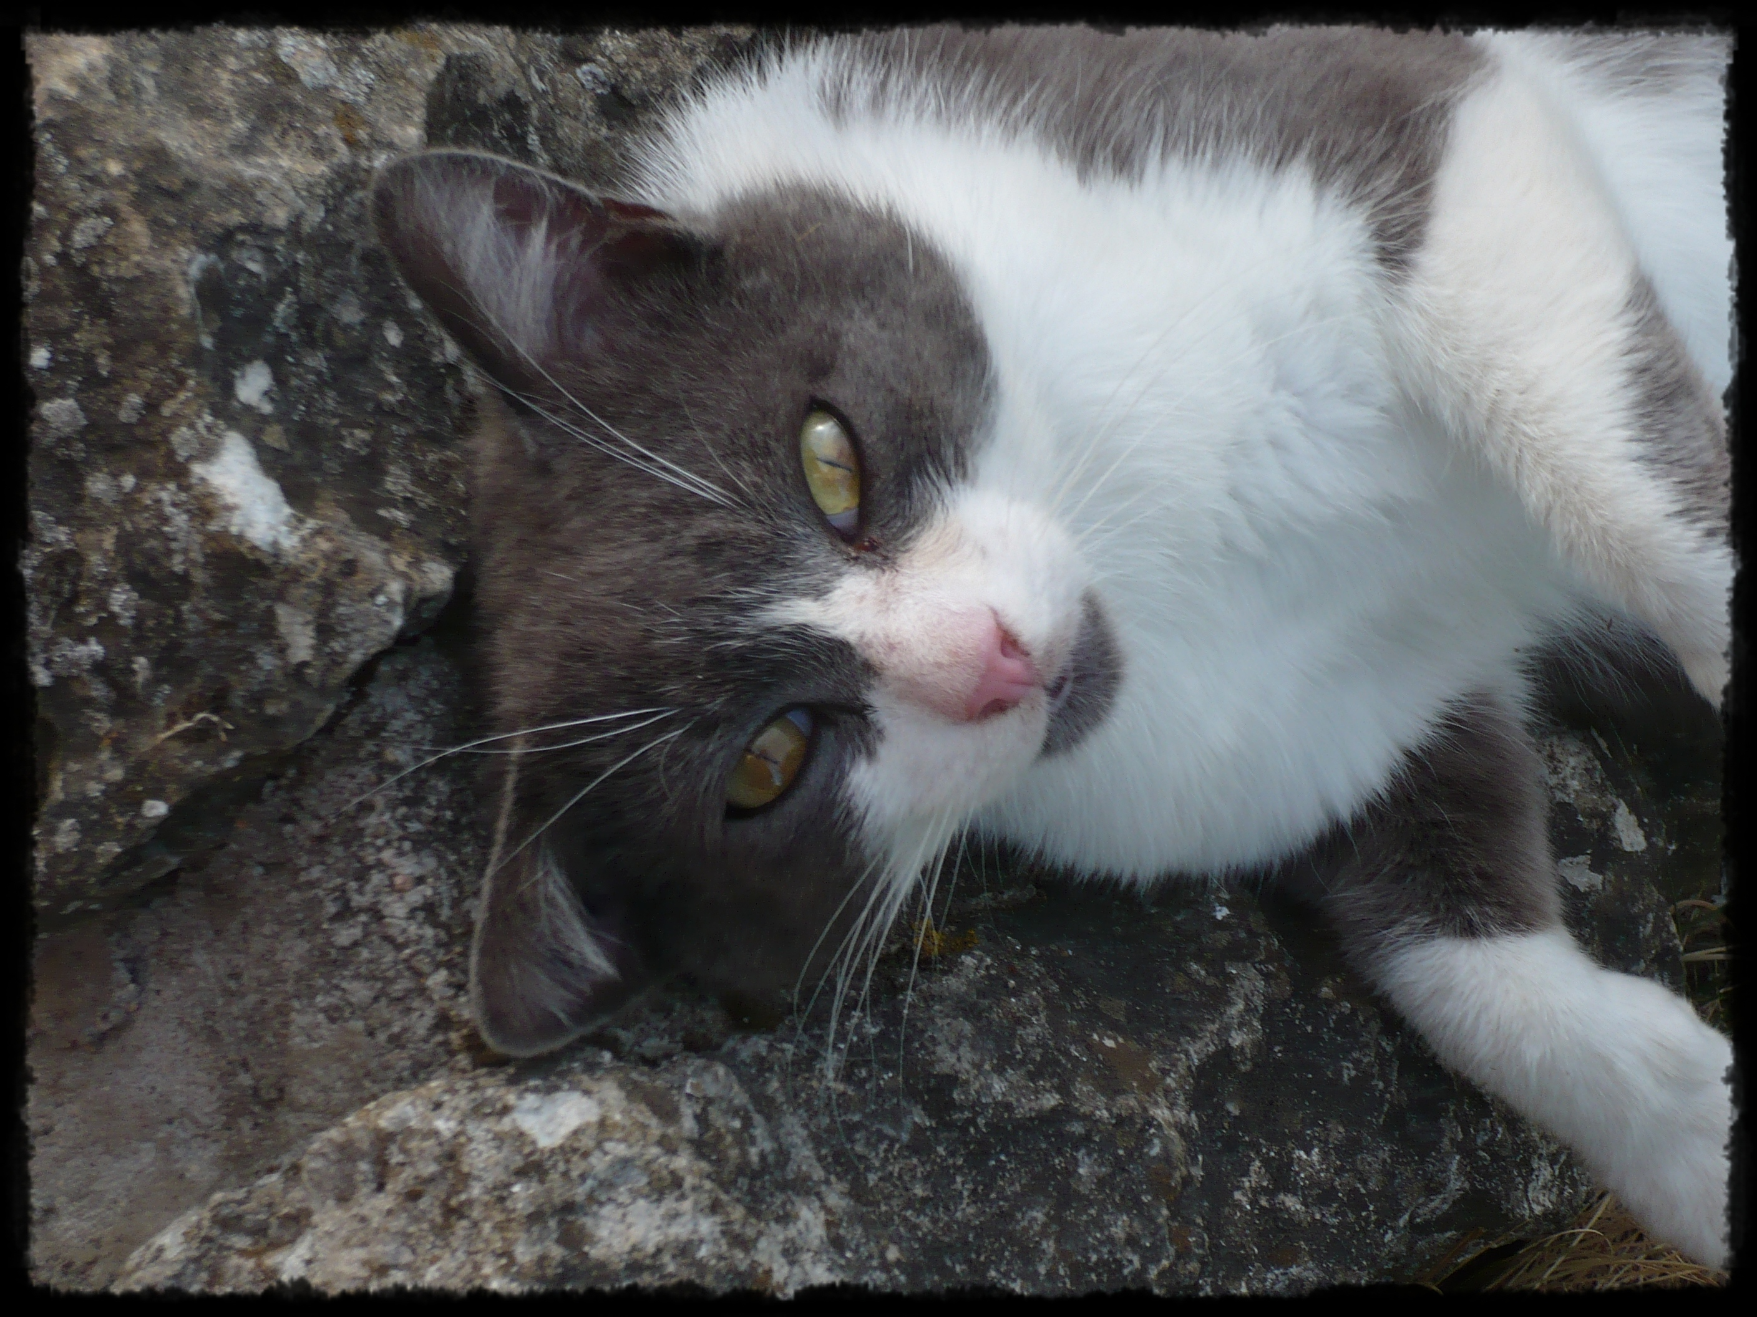
The class mascot Baboon

