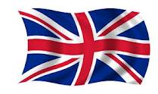
My personality quiz !
(Circle the correct answer )

1. What is your favorite subject? _Mathematics
_ History
_ French
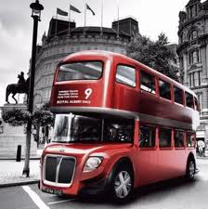
_ Sports
_ Science

2. What do you like doing? _ Hanging out with friends
_ Playing sports
_ relaxing

3. Do you like school ? _ Yes
_ No
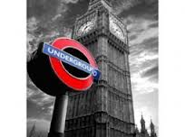
4. Do you have loads of friends ?
// // // loads of secrets ?
// // // loads of fun ?

5. What kind of music do you like? _ Rap
_ RnB
_ Pop music
_ Classical music

6. Which animal do you think you like the most ? Why ?
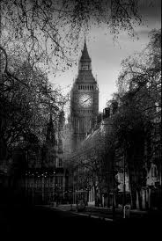
_ Dog
_ Monkey
_ Dove
_ Other

