Our school the Two Rivers

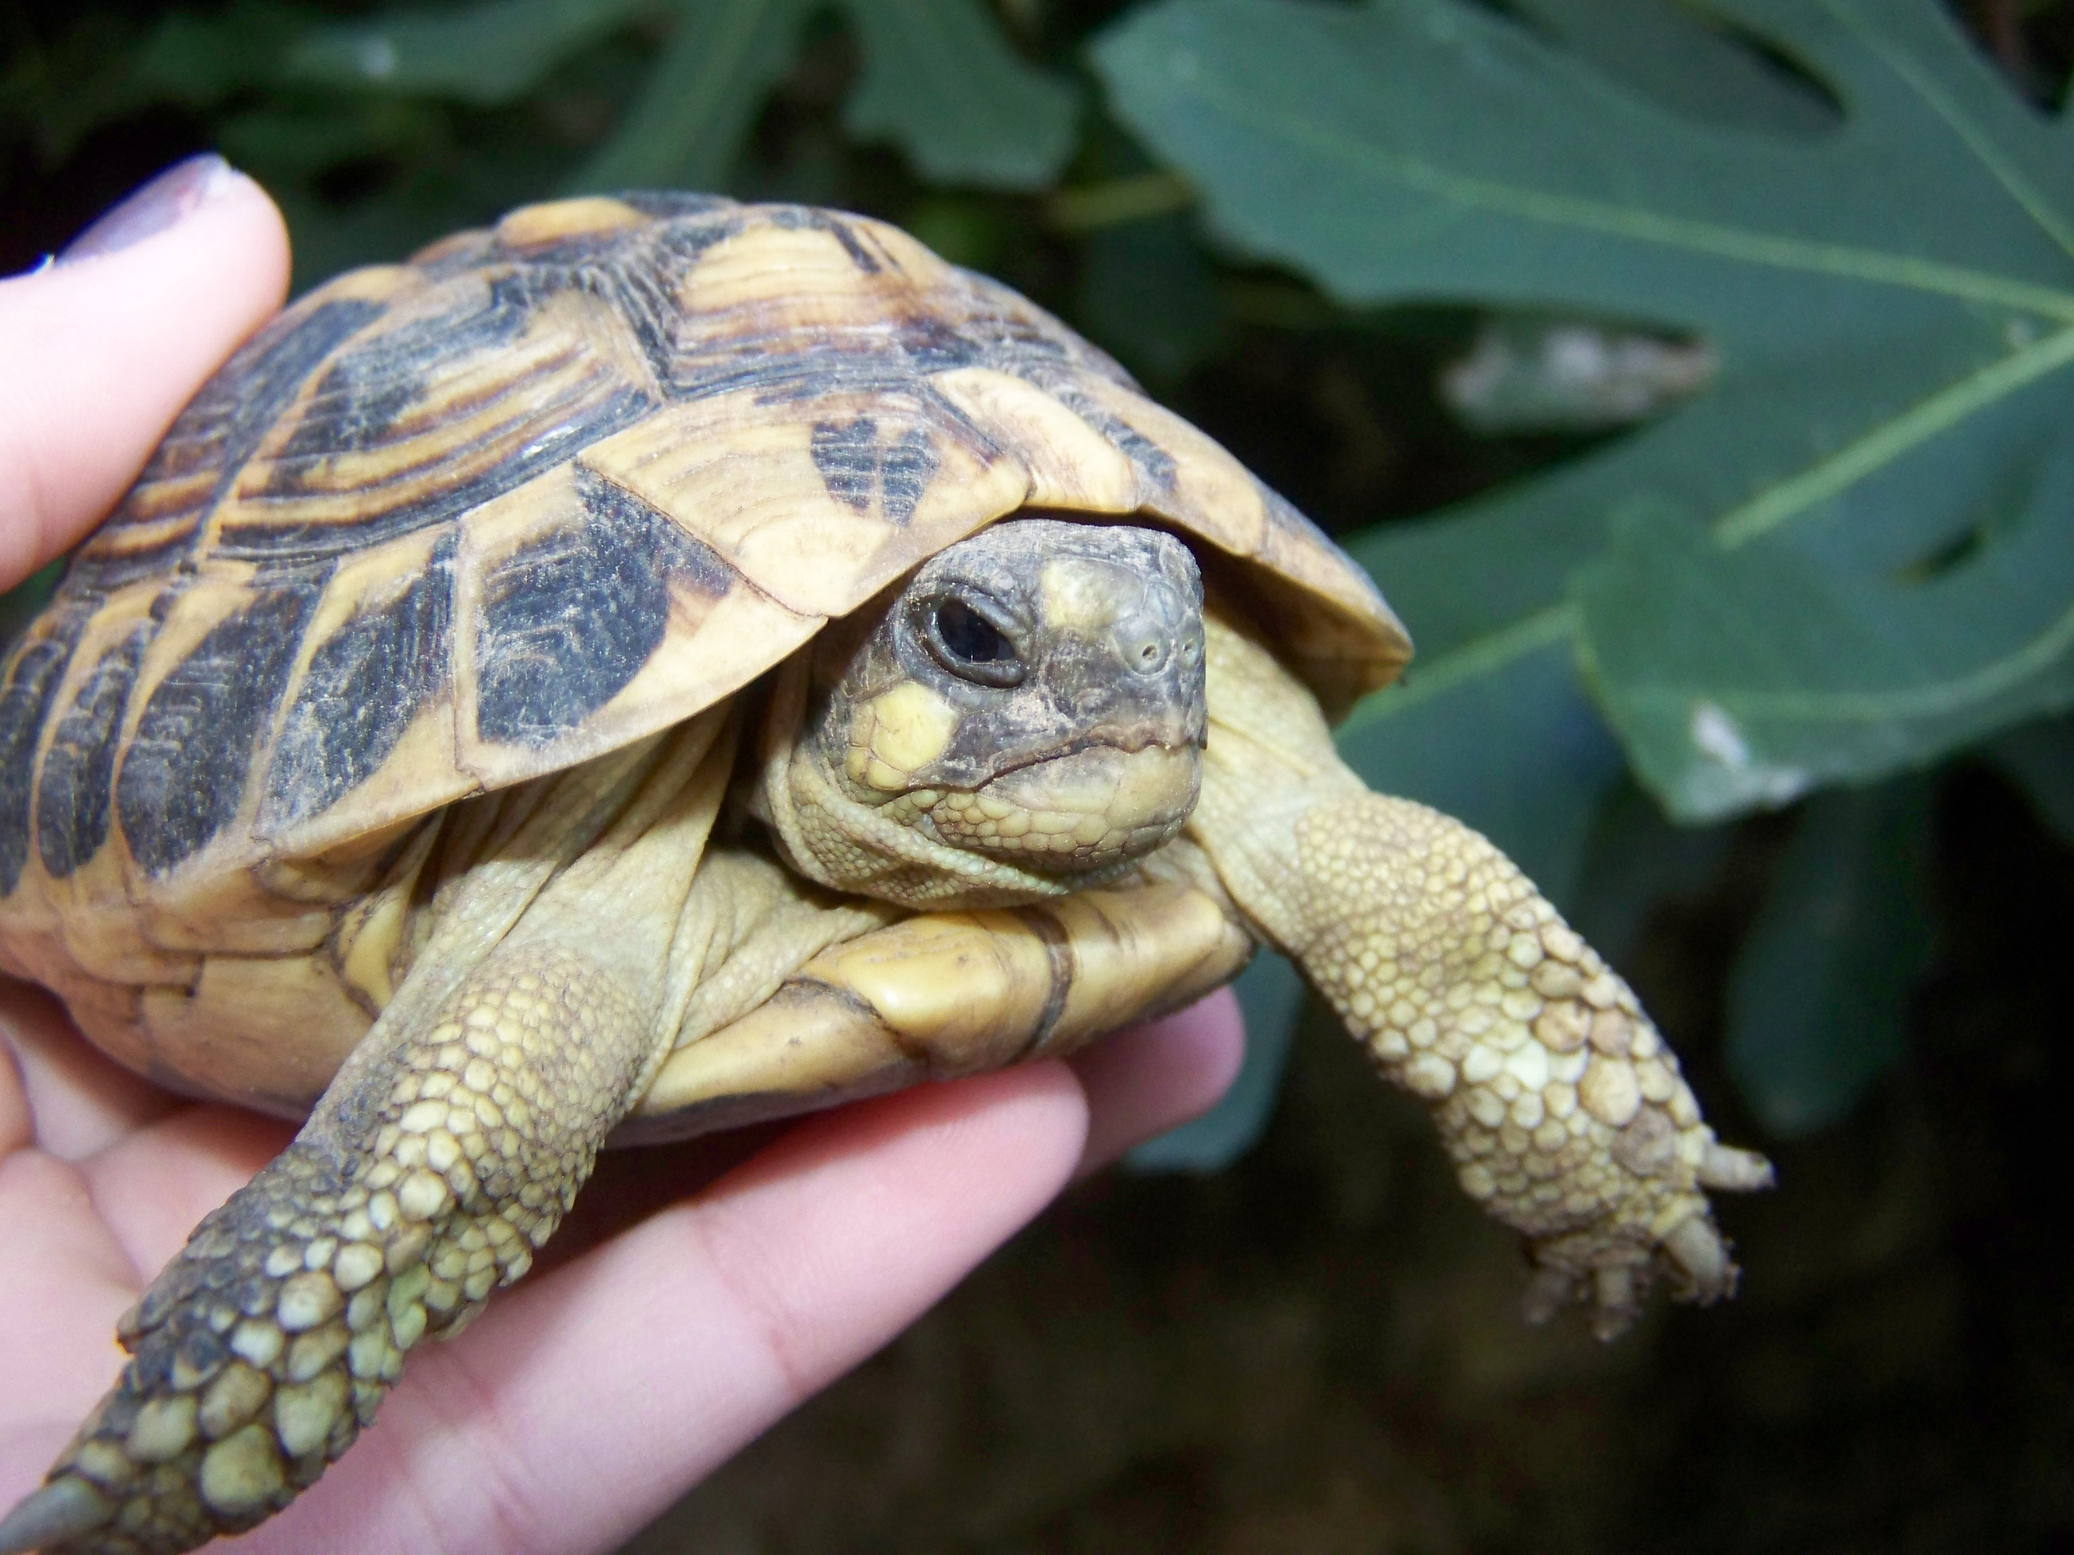
The school The Two Rivers is situated in Moulins – Engilbert . It was founded in 1959. It is a state school.

There are about 234 students and 20 teachers .

The class mascot is a tortoise. His name is Franklin.

The curriculum is very varied : the students can study usual subjects like English , French , Maths, History, Music, Arts. We can also learn Latin.

The lessons start at 8.30 am. There are 3 or 4 lessons in the morning . After that, it's the lunch time at 11.30 am or 12.30 pm . Next, there are 3 lessons in the afternoon.

At Moulins-Engilbert school, it's forbidden to use a mobile. It's forbidden to touch computers and ride a bike too. It is not allowed to run in the corridors. It's prohibited to smoke. We can't enter the staff room, but we can play table tennis in the playground.

I like my little school because I have very very good teachers .

Level 1

Play
room
Study room
Computer
room
Maths room
Latin
room

C
O
R
R
I
D
O
R

Playground
Hall
School Life office
Education advisor's office
School library
Science room
Science room
Head's office
Secretary's office
Staff room
C
O
R
R
I
D
O
R
Sick
room
Bursar's
office
Playground

2

dining hall

Level 2

Level 2

History
Geography
room
History
Geography
room
English room

C
O
R
R
I
D
O
R
Spanish room
French room
Maths room
Stairs
Little
Study
room
Music / Art
CORRIDOR

