The Personality Quiz
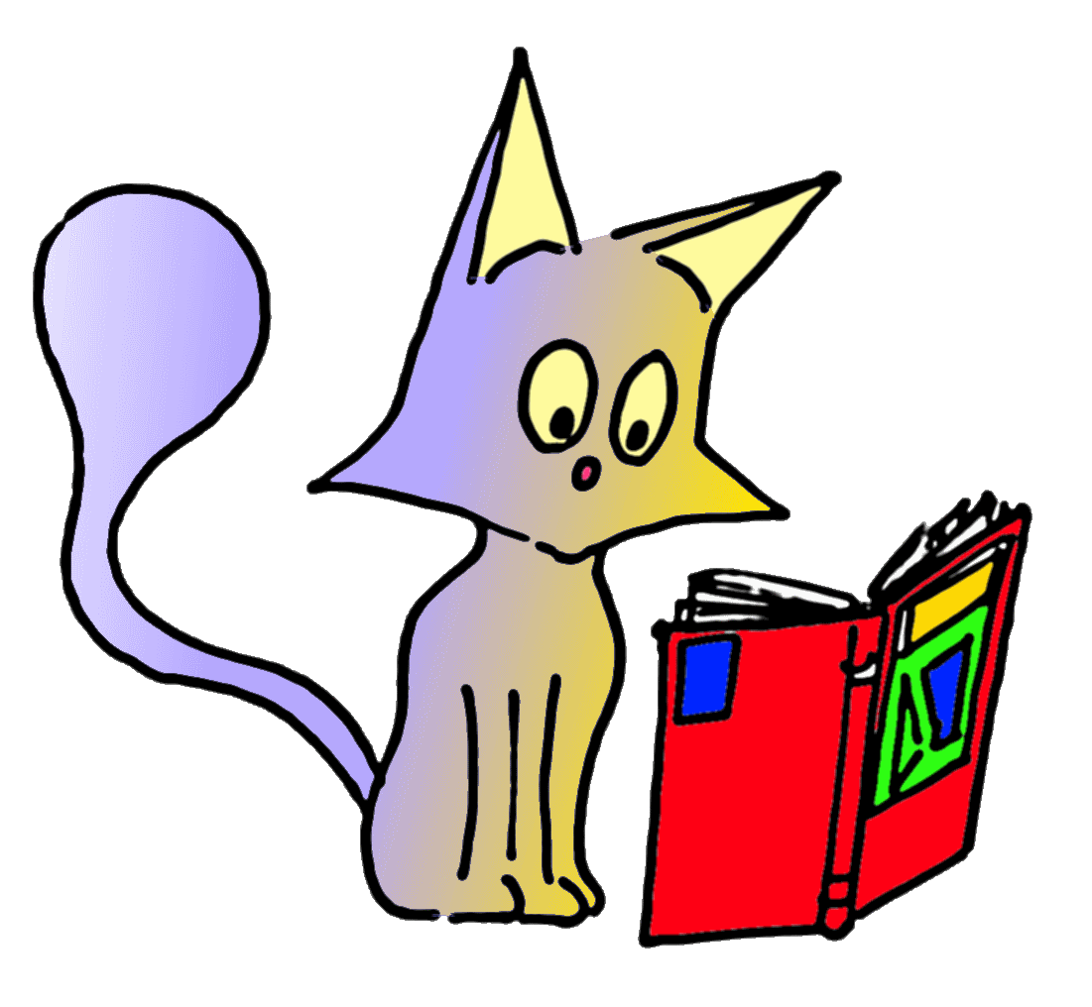
Do you have..
Loads of pets? Yes/No
Loads of clothes? Yes/No
Loads of books ? Yes/No
Loads of cds? Yes/No
Who do you have most in common with ?
Your brothers and sisters? Yes/No
Your mother and father ? Yes/No
Your best friend ? Yes/No
Your friends? Yes/No
What do you like doing at week-ends?
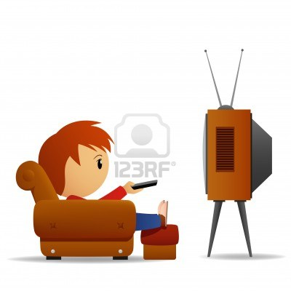
Listening to music?
Doing shopping?
Staying at home, watching TV?
Hanging out with your friends?
Others?
What are you like? Do you love…
Sneaky, rude, selfish, impolite and moody? Chocolate? Yes/ No
Bold, caring, cautious, brave and polite ? School? Yes/No
Extremely Not at… all Travels ? Yes/No
Surfing on the net ? Yes/No

